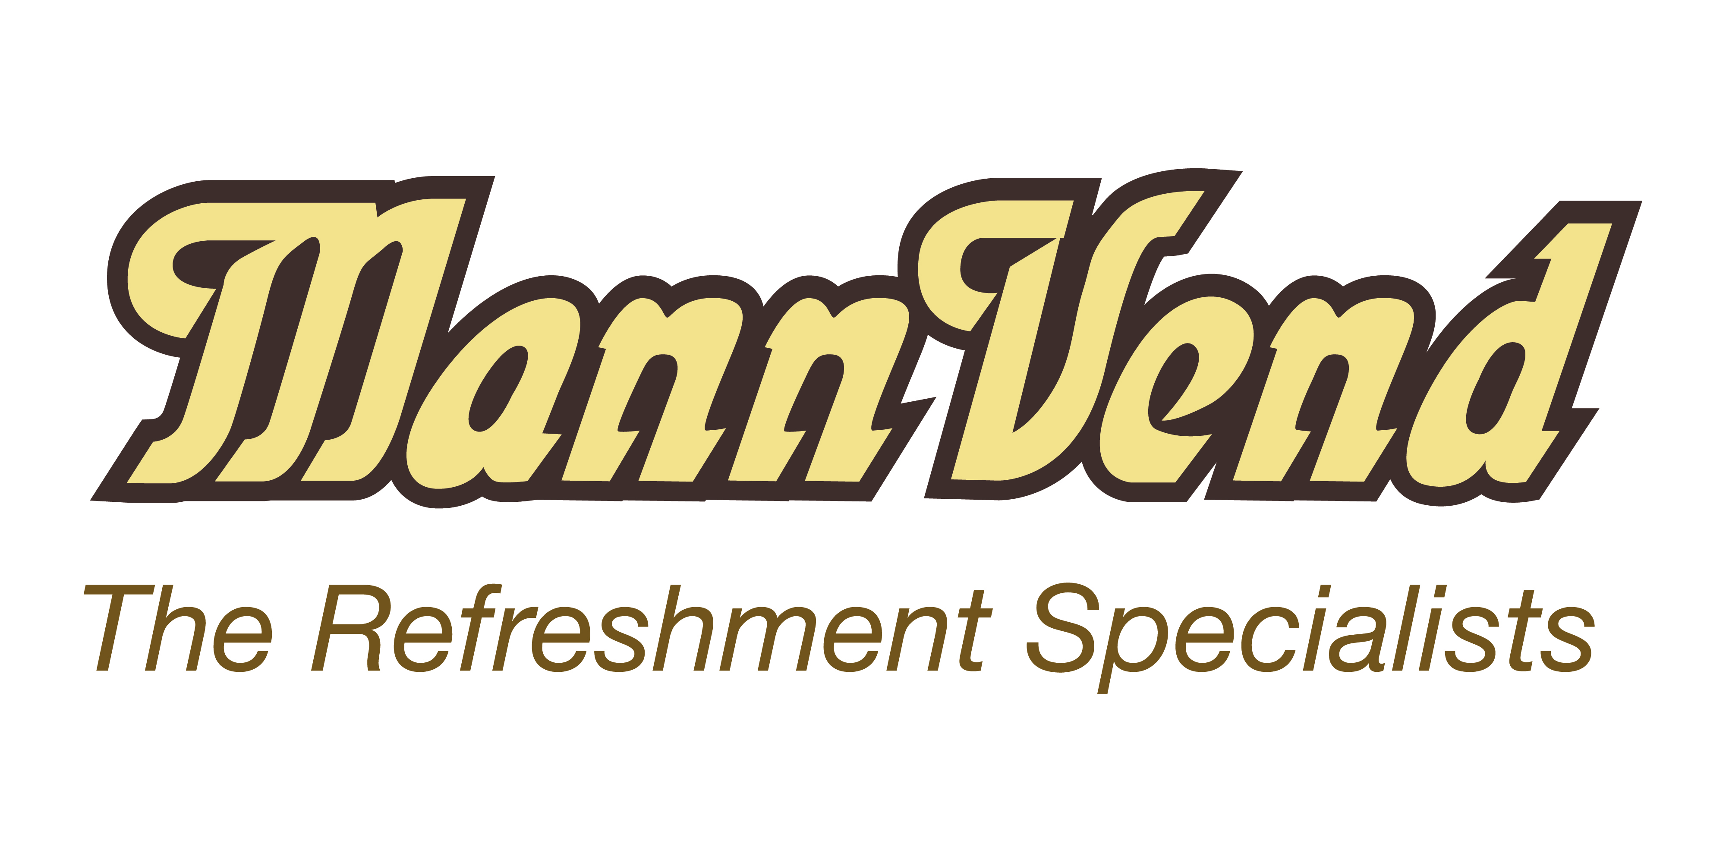

Job Description

Route Operator

Job Details

Reporting to: Operations Manager |  | Date: January 2023

Department: Operations |  | Location: customer sites

Responsible for: Replenishing and cleaning of vending machines on a regular round.

Job Summary

To replenish and clean hot drinks machines and snack and cold drink machines on customer sites across the Island to a high standard of service. Each route Operator has their own weekly round.

Key Responsibilities

Key Skills

- Clean full driving licence
- Excellent Communications Skills & the ability to mix with a range of people.
- Reliable
- Good attention to detail

Qualifications

- Secondary education

Personal Attributes

- Smart, neat appearance
- Non smoker
- Well organised

Experience
- No previous experience required as training will be given

Core Duties

- Restocking and cleaning hot Drinks, snacks and cold drinks vending machines to a high standard
- Would have own regular weekly round of customers to visit each day
- Time management of the operation of sites on a regular round
- Responsible for stock management of stock in van
- Transferring of stock by smart phone from warehouse to machines
- Overseeing the welfare of customer’s equipment
- Collection of cash from machines in sealed secure bags
- Representing Mannvend to a high standard
- Taking meter readings from machines
- Ability to display diplomacy when handling customer issues
- Advising management of opportunities for site improvements
- Responsible for safety checks of own company vehicle

